Requirements/Design Specification

**Capture/CRM Competitor Functionality**

**CR**

Revision History

|  |  |  |  |
| --- | --- | --- | --- |
| **Date** | **Revision** | **Description** | **Author** |
| 3/3/2014 | 1.0 | Initial Version with Requirements | Roger Behm |
|  |  |  |  |
|  |  |  |  |
|  |  |  |  |
|  |  |  |  |

The information furnished herein by Republic Services Inc. is proprietary and confidential to Republic Services Inc. personnel and is not to be duplicated, published, or disclosed to any third party in whole or in part without permission from Republic Services, Inc.

© Copyright 2012, Republic Services Inc. - All rights reserved.

Table of contents

1 Business Requirements 6

1.1 Purpose of the Design Specification 6

1.1.1 Business Functional Requirements / Configuration 6

1.1.2 Technical Design Requirements 6

2 Assumptions 6

3 Technical Design 6

3.1 Referenced Documents 6

3.2 Process Flow and Mock Ups 7

3.3 Functional Logic 9

3.4 Data Sources & Mapping 9

3.5 InfoPro Interface 9

4 Report Changes 9

5 Appendix 9

# Business Requirements

## Purpose of the Design Specification

This document highlights items to be implemented for Rate Restriction functionality. In order to get certain functionality to the users quicker, not all items will be implemented in this first iteration.

### Business Functional Requirements / Configuration

| **Business Functional Requirement** | **Notes** |
| --- | --- |
| Give Capture the ability to specify competitor acquisition based on each container within a quote. | On the config page display a dropdown list of the competitors for that division |
| Pricing | Current pricing formulas should not change. Currently only New/New and Waste Management have applied adjustments. |
| Doc Engine | In the event a quote as multiple competitors the transaction/reason and competitor codes will populate in the comments secion of the office use CSA. A list of transation reason codes can be found in the attachment. |

### Technical Design Requirements

| **Technical Design Requirement** | **Notes** |
| --- | --- |
| Config (Select Service Offering) page |  |
| Commerce |  |
| Documentation   * CSA * Proposal * Sample Invoice |  |
| InfoPro Interfce |  |

# Assumptions

The following items are assumptionsout of scope

Close Account functionality on last page

# Technical Design

## Referenced Documents

None

## Process Flow and Mock Ups

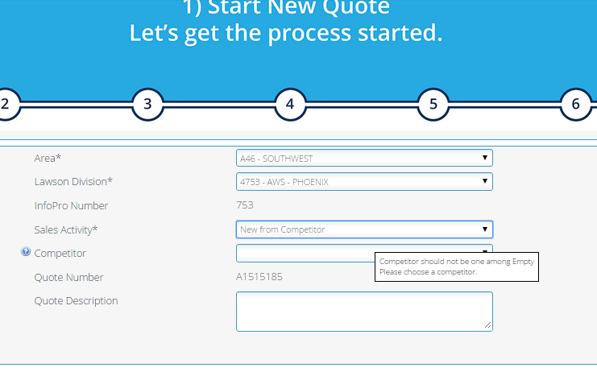

Remove:

* “New from Competitor” option from Sales Activity field
* Competitor Field
* Validation Rule



Add competitor field to New/NewSmall here

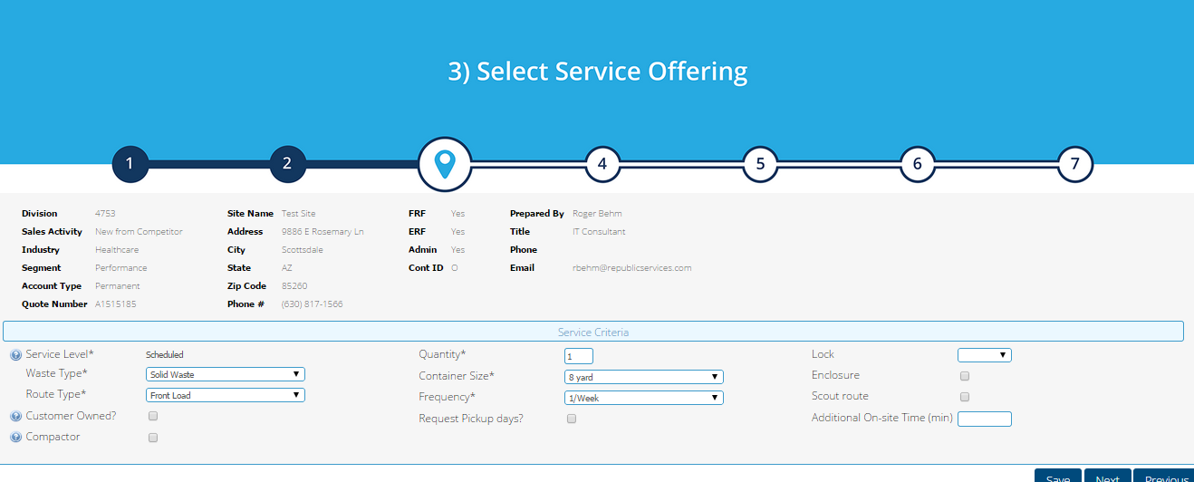

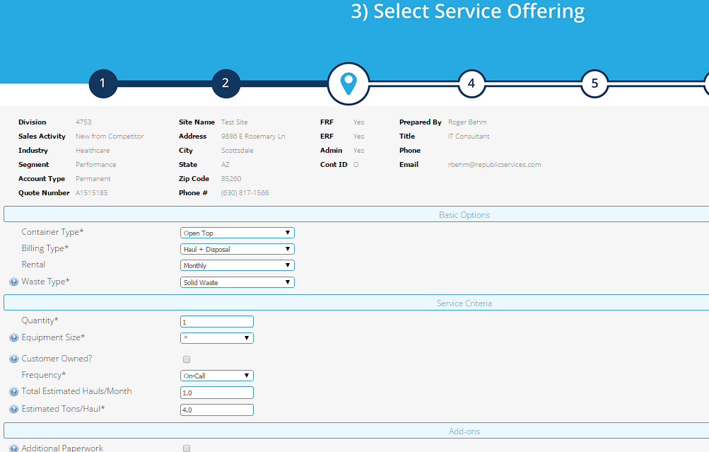

Add competitor field to New/NewLarge here

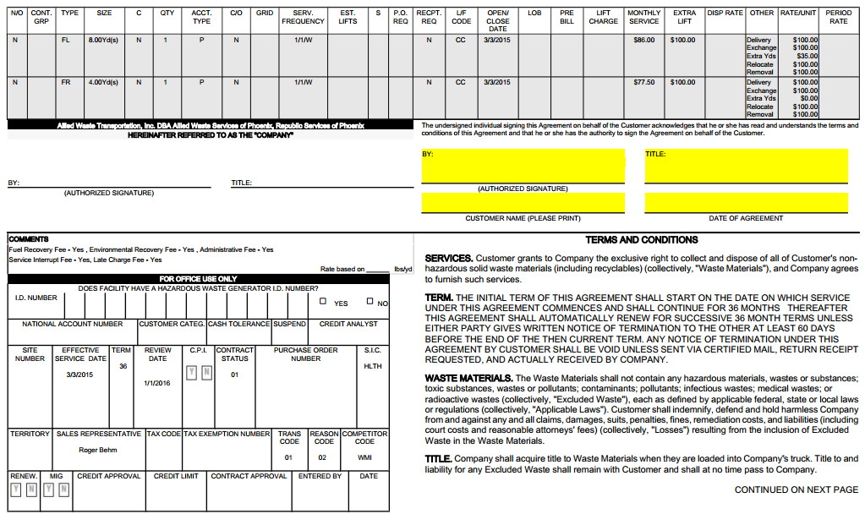

Add Tran/Reason Code and Competitor code to comments if mutli competitor container

## Functional Logic

NA

## Data Sources & Mapping

* For detailed mapping information, please refer to the BMI [Enterprise Mapping Document](http://itpmo-2013projects/Pricing%20Initiative/2.0%20Planning%20and%20Requirements/BMI%20Enterprise%20Mapping%20Document.xlsx).
* No additional data sources or mappings needed

## InfoPro Interface

The following tags will need to be consumed by the AAE process:

# Report Changes

No Changes

# Appendix